Continued Parent Teacher Conferences will be held on Wednesday and Thursday, March 14-15, 2018. The early dismissal times are as follows: 2:00 p.m. (Wednesday) and 1:30 p.m. (Thursday). We look forward to seeing you!

Please check out our Lost and Found area near the fish tank in the main lobby during that week. All unclaimed items will be donated locally after conferences. Thank you!

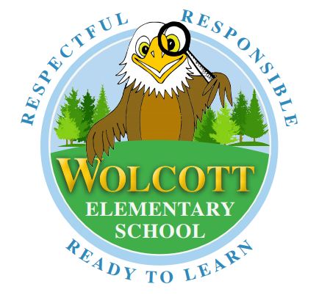
UPDATE DUE TO RECENT SNOW DAYS

